**PREDICTIVE MODELING OF STANDARD & POOR’S 500 (SPY) INDEX MOVEMENTS USING LONG SHORT-TERM MEMORY (LSTM) NETWORKS: A COMPREHENSIVE ANALYSIS**

**Abstract**

This study investigates the use of long short-term Memory (LSTM) models in predicting movements in the S&P 500 Index (SPY), which is known for its performance in the US stock market. Leveraging descriptive statistics, visualizations, time series analysis, and model development, the research aims to provide a comprehensive evaluation of the LSTM performance. While descriptive statistics show inconsistencies and deviations of SPY Index data, the plots show long-term and short-term changes**.** Time series analysis uncovers systematic directional movement and positive autocorrelation within the data. The development of the LSTM model shows good results with low root mean square error (RMSE) and high R-squared values, indicating its effectiveness in capturing diverse data. Findings are consistent with existing literature on financial forecasting, emphasizing the importance of robust predictive models in capturing complex market dynamics. The study suggests future research directions to address current methodological limitations and enhance predictive model accuracy. Overall, this research contributes to the understanding of machine learning in finance and provides insight to practitioners and researchers looking to improve the financial forecasting.

**Acknowledgments**

I would like to thank everyone who contributed to the completion of this research. First and foremost, I want to thank my supervisor for his invaluable guidance, support, and encouragement along the way. Their expertise, insight and sound advice are crucial in developing effective guidance and research. I am grateful to the participants who gave their time and insight, without whom this study would not have been possible. I am also grateful to my colleagues and friends for their friendship, collaboration, and discussions that have strengthened my understanding and thinking on the subject. I would also like to thank my family for their love, support, and understanding throughout the ups and downs of this research. Their support was a source of strength and motivation. Finally, I would like to thank the academic and administrative staff of Birmingham City University, whose help and resources were invaluable in completing this project. I would like to thank everyone who contributed to this effort in any way possible. Thank you very much for your support.

Table of Contents

**Introduction** 8

Rationale 9

Objectives 10

Scope 10

Methodology 11

Problem Definition 11

Scope 12

Rationale 12

Aims and objectives 13

Background Information 14

**Literature Review** 16

**Themes** 16

Theory 21

Summary 21

**Project Design and Methods** 23

Introduction 23

Methodology 23

Limitations and Options 24

Design Specification/User Requirements 25

Concept Solution 26

Testing Strategies 27

Backtesting 27

Cross-validation 28

Performance Metrics 28

Model Tuning and Re-evaluation 28

Design and Development 29

Testing 29

Summary and Conclusions 29

**Evaluation** 30

Evaluation Methodology 30

Evaluation Metrics 30

Baseline Systems 30

Dataset 31

**Results** 32

Description of Variables 32

Long short-term Memory Model Development 38

Discussion 40

**Conclusion** 42

**Reference List** 43

**Glossary**

|  |
| --- |
| LSTM Long Short-Term Memory |
| MAE Mean Absolute Error |
| ML Machine Learning |
| MSE Mean Squared Error |
| RMSE Root Mean Squared Error |
| SVM Support Vector Machines |

**List of tables**

Table 1**-Descriptive statistics** 33

**Table 2– Mean and Variance** 36

**Table 3- Root Mean Square Error and R-squared** 39

**List of Figures**

Figure 1 **- Flow Diagram** 25

Figure 2**- Data Visualization** 34

Figure 3 35

**Figure 4- White Noise** 36

**Figure 5-Time Series Decomposition of SPY Index Prices** 38

**Figure 6-Actual Prices vs Predicted Prices.** 39

# **Introduction**

Machine Learning (ML) has been creating significant impact across various sectors, including finance. The ability to analyze large amounts of data, identify patterns and make predictions has proven invaluable in the financial industry. This study specifically delves into the utilization of ML in quantitative finance, particularly for forecasting movements in the Standard & Poor’s 500 (SP) index.

Quantitative finance entails employing mathematical models and statistical methods to comprehend and foretell market trends. It holds a vital role in diverse financial activities such as trading, investment management, risk assessment, and market regulation. The SPY index, synonymous with the performance of 500 major companies on the US stock market, stands out as one of the most closely monitored stock indices globally. Accuracy in predicting the SPY index greatly interests investors, traders, and financial institutions alike.

The main objective of this project is to use machine learning technology to develop a predictive model to predict the volatility of the SPY index. By training the model on historical SPY index data, it can glean insights from past market trends to make informed predictions about future shifts. This methodology harnesses the potential of ML to navigate vast datasets and intricate patterns, which are characteristic of financial markets.

Developing an ML-driven predictive tool not only aims to enhance the precision of SPY index forecasts but also signifies a progression towards a broader integration of ML in financial decision-making processes. As ML advances and progresses, it is anticipated to assume a more crucial role in quantitative finance. Consequently, this project contributes to the ongoing endeavors to leverage the potential of ML in finance.

Furthermore, the project incorporates a comprehensive review of literature concerning the application of ML in quantitative finance. Drawing insights from a variety of sources, this review establishes a theoretical basis for the project. It delves into essential themes and emerging trends in the domain, shedding light on how ML is being employed to address financial challenges and what the future may entail.

In conclusion, this project epitomizes an exciting fusion of ML and quantitative finance. Through the development of an ML-based tool for SPY index forecasting, the intention is not only to refine financial predictions but also to advance the integration of ML in the finance sector at large. This initiative underscores the transformative capacity of ML in finance, setting the stage for future innovation and research in this arena.

## Rationale

The rationale behind this study is rooted in the potential for machine learning to transform predictions within financial markets. Our primary focus is on creating a tool to predict in the S&P 500 Index (SPY). Traditional financial models, though valuable, often face challenges in dealing with the dynamic and intricate nature of financial markets. In contrast, machine learning can learn from data and adjust its predictions over time, making SPY more capable of predicting index movements. Through the development of a machine learning-driven tool, our goal is to offer more precise and timely predictions, assisting investors in making well-informed decisions. This research has the potential to pave the way for a new generation of financial marketing tools in which machine learning plays a key role.

## Objectives

**Primary Objective**

The main goal of this research is to develop a tool that can predict changes in the S&P 500 Index (SPY) using advanced machine learning techniques. The SPY index is widely considered a key indicator of US stock market performance. Developing an accurate prediction tool could offer valuable insights for both investors and financial analysts.

**Secondary Objectives**

1. Investigate the current utilizations of Machine Learning (ML) in quantitative finance to pinpoint areas where it can offer substantial benefits. This includes grasping how ML can boost predictive precision, facilitate real-time analysis, and streamline the management of extensive datasets.
2. Recognize the obstacles and restrictions linked to the implementation of ML in quantitative finance, such as overfitting, interpretability issues, and concerns about data quality. This task examines common mistakes when applying ML to financial data and deliberating on tactics to alleviate these hurdles.
3. Assess the effectiveness of the SPY predictor tool by gauging the precision, dependability, and resilience of the forecasts produced by the ML model. The assessment will not involve a comparison with traditional financial models; instead, it will center on the independent performance of the ML model. This approach ensures the focus remains on the capabilities and potential of the ML model in predicting the SPY index.

By focusing on these objectives, the study will offer a thorough insight into the potential of ML in forecasting the SPY index, contributing to the continual progression of quantitative finance.

## Scope

The focus of this study revolves around using supervised learning methods to predict the SPY index. Supervised learning is a form of machine learning where the model is on labeled data, meaning a dataset where the target variable (in this instance, the future value of the SPY index) is known (Nasteski, 2017: pg.56). This method is well-suited for predictive tasks and has proven successful across various sectors, including finance.

## Methodology

The methodology for this research will involve several steps:

**Literature Review**

Conducting an extensive literature review is essential to pinpoint key themes regarding the utilization of Machine Learning (ML) in quantitative finance. This review will refer to a minimum of eight relevant sources to ensure a comprehensive grasp of the subject matter (Dixon et al., 2017: pg 50).

**Development of the SPY Predictor Tool**

The creation of the SPY predictor tool will involve the utilization of an appropriate supervised learning algorithm. This tool will undergo training and testing on historical SPY index data to confirm its efficacy. This procedure will entail the selection of suitable features, adjustment of hyperparameters, and assessment of the model's performance using fitting metrics.

**Evaluation of the SPY Predictor Tool**

This overview provides a detailed insight into the research topic, its reasoning, objectives, scope, and methodology. Subsequent sections of the thesis will delve deeper into these aspects, providing an exhaustive examination of how ML is applied to forecast the SPY index. This methodology guarantees that attention is maintained on the capabilities and potential of the ML model in predicting the SPY index.

## Problem Definition

The task at hand involves creating a machine learning-based tool to accurately predict the movements of the Standard & Poor’s 500 (SPY) index. This endeavor holds significance as precise predictions can shape investment decisions, risk management strategies and policy-making in the finance sector. SPY predictor tool aims to harness the use of machine learning to offer a more precise efficient prediction tool for the finance industry This study will contribute to the continuous integration of machine learning in finance operations, enhancing the precision of financial forecasts. It will also enrich the existing knowledge on utilizing machine learning in the realm of finance.

## Scope

The scope of this project is the utilization of machine learning strategies within the field of quantitative finance, particularly in forecasting the Standard & Poor's 500 (SP) index. The project entails creating and assessing a predictive tool for SPY using supervised learning methods. This tool will undergo training and testing with historical SPY index data, showcasing a practical application of machine learning in finance.

Additionally, the project involves an extensive analysis of the literature regarding machine learning in quantitative finance. This review will pinpoint significant themes and draw insights from a minimum of eight credible sources, establishing a theoretical groundwork for the project. Despite the broad spectrum of machine learning techniques available, this project will concentrate exclusively on supervised learning due to its established efficacy in forecasting. Other methods like unsupervised learning and reinforcement learning are beyond the project's scope. Furthermore, while the SPY index serves as a broad representation of the U.S. stock market, it is just one of numerous financial indices. The project does not delve into the application of machine learning for predicting other indices or individual stocks.

The project's scope is rationalized by the necessity for more accurate and efficient prediction tools in finance. By focusing on a specific, practical use of machine learning – the SPY predictor tool – the project aims to contribute to the ongoing integration of machine learning in financial decision-making processes. The deliberate exclusion of other machine learning methods and financial indices enables a more focused and thorough examination of the selected subject. This scope is supported by research indicating the potential of machine learning within finance.

## Rationale

There is a rising interest in the connection between machine learning and finance; however, there is a noticeable gap in research specifically focusing on using machine learning to predict financial indicators such as the SPY index. This project aims to fill this gap by creating a tool that predicts SPY using machine learning techniques.

The reason for selecting this topic is in response to the finance industry's demand for more precise and effective prediction tools. Traditional financial models often struggle to accurately predict market shifts due to their incapacity to adjust to the continually changing and intricate nature of financial markets. Machine learning, on the other hand, displays promise as an alternative method by learning from data and adapting its predictions over time.

The advantages of completing this project extend beyond academic curiosity. Developing a SPY predictor tool with machine learning techniques can provide substantial benefits to various stakeholders in the finance sector. For investment banks and hedge funds, a reliable SPY predictor tool can assist in making investment decisions and managing risks, potentially enhancing financial performance.Financial analysts can gain insight into the market and trends that will help with their analysis and forecasts. Additionally, regulatory bodies can utilize the knowledge of machine learning in finance to make informed policy and regulatory decisions.

Furthermore, this project can benefit the broader communities of machine learning and finance research by contributing to the knowledge on applying machine learning in finance. It may encourage further research in this domain and potentially lead to the development of more advanced and effective machine learning-based financial prediction tools.

In conclusion, the rationale behind selecting this topic lies in the research gap, industry demand, and the possible advantages for various stakeholders in the finance industry. This project aims to not only enrich academic knowledge but also offer practical solutions to real-world challenges in finance.

## Aims and objectives

The project's objective is to utilize machine learning techniques to create a forecasting for the Standard & Poor’s 500 (SPY) index. This goal is driven by the necessity for more precise and effective prediction tools in the financial sector, as well as the potential of machine learning as viable. Achieving this would enhance the knowledge base of quantitative finance and deliver useful tools for various in the finance industry.

**Objectives**

To accomplish this project's objective, the following steps have been outlined:

1. **Review of Literature:** Conduct an extensive review of literature to analyze current uses of machine learning in quantitative finance. This work includes defining key themes, understanding the benefits and challenges of machine learning in these contexts, and gaining insight from at least eight sources.

2. **Development of the SPY Predictor Tool:** Create a SPY predictor tool using supervised learning methods. This step includes training and testing the tool on historical SPY index data to ensure its efficacy in predicting future index movements.

3. **Assessment of the SPY Predictor Tool:** Evaluate the performance of the SPY predictor tool compared to traditional financial models. This phase involves appraising the tool's accuracy, dependability, and potential advantages over conventional methods.

**4. Knowledge Contribution:** Add to the expanding knowledge base on applying machine learning in finance. This objective involves documenting the creation and assessment process of the SPY predictor tool and discussing the insights gained from its implementation.

These goals are SMART (Specific, Measurable, Achievable, Relevant, and Time-bound) and are designed to accomplish all goals in a timely manner. They focus on addressing the current issue and are distinct from the academic aspects of the module. Each objective aligns with the feedback from the supervisor and has been mutually agreed upon. The successful completion of these objectives will result in a practical resolution for a real-world financial issue and a significant contribution to academic understanding.

## Background Information

The background information for this project is rooted in the field of quantitative finance and machine learning.

**Quantitative Finance**

Quantitative finance involves the use of mathematical models and big data to analyze financial markets and securities. It is a discipline that has existed for decades and plays an important role in the development and risk management of complex financial instruments.

**Machine Learning in Quantitative Finance**

Machine learning holds great promise against the challenges faced thanks to its ability to learn from data and adapt when necessary. Its ability to navigate the complex and ever-changing financial market environment means it can be an effective tool for financial forecasting. By employing machine learning strategies with the extensive datasets in quantitative finance, we can craft adaptable models that can respond to shifting market dynamics and yield more precise forecasts. This forms the foundation of our project - utilizing machine learning's potential in predicting the Standard & Poor’s 500 (SP) index. This method strives to enhance financial decision-making processes by incorporating machine learning and enhancing the accuracy of financial forecasts. It also contributes to the expanding knowledge base regarding machine learning's application in finance.

**Machine Learning**

Machine learning, a form of artificial intelligence, utilizes algorithms that can understand and make decisions or forecasts according to data. Over the recent years, machine learning has displayed significant potential across various sectors, especially in finance. It has the ability to learn from data and adjust its predictions while improving its effectiveness as a financial forecasting tool.

**Hypothesis**

This project will test the hypothesis that states: A predictive model utilizing machine learning methodologies can offer precise forecasts regarding the movements of the SPY index. This hypothesis revolves around the capacity of machine learning to accurately predict shifts in financial markets, particularly focusing on the SPY index. It emphasizes the project's objective of utilizing machine learning for financial forecasting.

**Theory**

The cornerstone theory of this project is the Efficient Market Hypothesis (EMH), which asserts that financial markets constantly operate at optimal efficiency, implying that consistent above-average returns are unachievable. However, should a machine learning model accurately predict the fluctuations of the SPY index, it would challenge the EMH and potentially grant investors a means of attaining surpassing returns.

This foundational information offers the necessary backdrop for comprehending the pertinent issue and the potential resolution sought by this project. It also paves the way for the exploration, in greater depth, of the current applications of machine learning in quantitative finance through a literature review. The hypothesis and theory stated will be scrutinized and validated throughout the project's duration.

# **Literature Review**

The utilization of machine learning within quantitative finance has seen significant growth in research activities during the last ten years. Machine learning algorithms' capability to analyze data and predict outcomes makes them well-suited for financial forecasting, such as anticipating fluctuations in the Standard & Poor’s 500 (SPY) index. Nevertheless, despite the promising aspects of machine learning, its implementation in finance faces various obstacles. Challenges related to overfitting, data integrity, interpretability, and model resilience frequently arise, creating substantial barriers to crafting dependable and efficient predictive models. This literary examination seeks to present a thorough synopsis of the current research landscape in this domain. It covers many of the key concepts needed to use machine learning to improve SPY's predictive models, including the role of machine learning in finance, forecasting models, the study of financial forecasting models, SPY index forecasts, and issues and limitations in financial forecasting. Each theme is thoroughly scrutinized, drawing insights from various sources to offer a well-rounded and exhaustive insight.

# **Themes**

**Application of Machine Learning in Finance**

Machine learning is increasingly being utilized in the finance sector because of its capacity to manage extensive datasets and provide precise forecasts (Huang et al., 2020: pg. 69). Financial institutions are using machine learning algorithms to anticipate market trends, handle risks, and optimize portfolios (Dixon et al., 2020: 25). Techniques like regression analysis, decision trees, and neural networks within machine learning have been employed to foresee stock prices and market movements (Kumar and Thenmozhi, 2016: 56).

Nonetheless, incorporating machine learning in finance encounters challenges. Financial data is often complex, constantly changing, and multidimensional posing obstacles for machine learning algorithms (Sirignano and Cont, 2019: pg. 23). Also financial forecast, market evaluation, company's fundamental, market sentiment etc. It is affected by many factors, such as, all of which need to be accurately captured by machine learning models (Atsalakis and Valavanis, 2009: 46).

Despite these challenges, machine learning shows great potential in finance. With the rise of big data and improvements in computing power, machine learning algorithms can analyze extensive financial data for precise predictions (Bao et al., 2017: pg. 56). Additionally, machine learning models can adapt to evolving market conditions, providing a dynamic resource for financial forecasting (Dixon et al., 2020: pg. 34).

**Predictive Modeling Techniques**

Forecast models are essential for financial forecasting. These methods range from statistical methods to more advanced machine learning algorithms, and each has its own advantages and disadvantages (Hastie et al., 2009: pg.35). Statistical techniques like linear regression and time series analysis are commonly used for financial forecasting due to their simplicity and clarity. However, they may assume linearity and stationarity in data, which may not be valid in dynamic financial markets (Tsay, 2005: pg. 6).

On the other hand, machine methods can capture non-linear relationships and patterns in data. Learning techniques such as decision trees, support vector machines, and neural networks have been shown to be effective in financial forecasting (Dixon et al., 2020; pg. 107). These methods learn how to map input features like historical prices and economic indicators to a target variable such as future prices from labeled datasets (Hastie et al., 2009: pg. 62).

Deep learning is a branch of machine learning that is becoming increasingly popular in financial forecasting because it can model complex relationships and extract relevant features (Samek et al., 2017: 87). However, deep learning models are criticized for their lack of clarity, which is crucial in finance.

Although many predictive models have been developed, it is still difficult to choose the appropriate model for a particular project. Factors such as the nature of the data, the prediction task, and the balance between model complexity and transparency must be taken into account (James et al., 2013: 67). Choosing the right tools based on specific projects and information is crucial for good financial forecasts.

**Evaluation of Financial Predictive Models**

Assessing the performance of predictive models plays a crucial role in financial prediction. This process involves evaluating the precision, dependability, and resilience of the models in anticipating future movements in the financial markets (Hyndman Athanasopoulos, 2018: pg. 90).

Precision is typically the primary factor examined during model assessment. It gauges how closely the model's predictions align with the actual values. Nonetheless, in financial forecasting, precision alone may not suffice. Financial data tends to be noisy and unstable, and a model performing well on one dataset may not deliver the same results on another (Baestaens et al., 2015).

Dependability relates to the consistency of a model's performance across various datasets or time frames. A dependable model should uphold a consistent level of precision even amidst changing market conditions. This aspect holds significant importance in finance, where markets exhibit dynamism and unpredictability (Dunis et al., 2016).

Resilience denotes a model's capacity to perform effectively despite alterations in input data or parameters. A resilient model should be able to manage outliers, missing data, and other anomalies without experiencing a substantial decline in performance (Pinto et al., 2016: pg. 46).

Multiple methods are utilized for assessing the performance of predictive models in finance. For example, backtesting involves evaluating the model's performance on historical data to evaluate its accuracy in predicting actual market conditions (Bailey and Lopez de Prado, 2014: 56). In contrast, validation should split the data into training and testing, training the model on the first and then evaluating its performance on the second (Arlot and Celisse, 2010: pg. 60).

Assessing the efficiency of financial predictive models presents a complex endeavor that necessitates consideration of various factors and metrics. Despite the challenges involved, thorough model evaluation is pivotal for establishing reliable and resilient predictive models in the realm of finance.

**SPY Index Prediction**

The Standard & Poor’s 500 (SPY) index is widely acknowledged as a key indicator of the performance of the U.S. stock market. It consists of 500 large companies that are publicly listed on stock exchanges in the United States, around 80% of the total market capitalization. Therefore, the fluctuations in the SPY index offer a comprehensive overview of the U.S. equity market and the overall economic situation.

Forecasting changes in the SPY index is a complex endeavor that has garnered significant interest from both researchers and professionals. The complexity arises from the multitude of factors that impact market trends. These factors encompass macroeconomic indicators such as GDP growth rates and inflation, as well as company-specific fundamentals like earnings reports and dividend declarations, along with broader aspects such as geopolitical events and investor sentiment. The intricate interplay of these variables determines the movement of the SPY index.

In recent times, machine learning methods have emerged as powerful tools for predicting fluctuations in the SPY index. These techniques are capable of handling vast amounts of data and identifying non-linear correlations, making them well-suited for financial forecasting tasks. Decision trees, support vector machines, and neural networks have been utilized to model the intricate dynamics of the SPY index (Kumar and Thenmozhi, 2016). These models learn from historical data and adjust their predictions over time, offering a dynamic approach to forecasting the SPY index.

Nonetheless, predicting the SPY index comes with its share of challenges. Financial markets are inherently volatile and influenced by numerous factors, many of which are hard to quantify or forecast accurately. Moreover, the SPY index encompasses a wide array of sectors and companies, each with its distinct dynamics, adding another layer of complexity to the prediction process.

In conclusion, while forecasting the SPY index poses significant challenges, machine learning techniques provide a promising avenue. By capturing intricate patterns in the data and adapting to evolving market conditions, machine learning models could potentially offer more precise predictions of the SPY index. However, the efficacy of these models ultimately hinges on the quality of the input data and the suitability of the machine learning approach chosen.

**Challenges and Limitations in Financial Prediction**

Financial forecasting, especially when predicting movements in the SPY index, presents various challenges and constraints. These obstacles arise from the intricate nature of financial markets, the limitations of forecasting techniques, and the characteristics of financial data.

The financial markets are impacted by a wide range of factors, from macroeconomic indicators to investor sentiment, and even geopolitical occurrences. These factors intertwine in intricate and sometimes unpredictable ways, shaping market trends. Creating an accurate predictive model that captures these dynamics is particularly arduous. Moreover, financial markets are prone to sudden upheavals and shifts, which can disrupt a previously reliable model (Hastie et al., 2009: pg. 46).

Although predictive modeling techniques are potent tools, they come with restrictions. For instance, while machine learning models can grasp non-linear relationships, they often necessitate substantial data volumes and computational power. They are also susceptible to overfitting, wherein the model closely fits the training data but performs poorly on new data (James et al., 2013: pg. 565).

The quality and nature of financial data add another layer of difficulty. Financial data is often turbulent, non-stationary, and multi-dimensional. These characteristics can obscure the underlying patterns, making it challenging for predictive models to discern them (Bailey and Lopez de Prado, 2014: pg. 126). Additionally, financial data is vulnerable to various forms of manipulation and bias, further complicating the prediction process.

In closing, although financial prediction holds significant promise, comprehending the associated challenges and limitations is vital. By recognizing these hurdles, researchers and practitioners can craft more resilient and dependable predictive models for financial forecasting.

## Theory

The principles of statistical learning form the theoretical basis for utilizing machine learning in finance. Statistical learning theory offers a framework for comprehending how well machine learning algorithms perform, especially in terms of their capacity to generalize from known data to unknown data. This aspect is critical in financial forecasting, where the objective is to make precise predictions about future market trends based on past data.

In the context of forecasting the SPY index, supervised learning theory holds particular significance. Supervised learning algorithms are designed to learn a function that links input data (such as historical SPY index information) to a desired output (like the future SPY index value) using labeled training data (bell, 2020: pg. 456). The selection of an algorithm, whether it is a linear model like linear regression, a decision tree, or a neural network, depends on the specifics of the data and the particular forecasting goal.

However, applying these algorithms in the financial domain is complex due to the distinct characteristics of financial data. Financial data frequently exhibits non-stationarity, indicating that the fundamental data distribution evolves over time. This contravenes the typical assumption in machine learning that training and testing data originate from the same distribution. The concept of non-stationary learning gives guidance on how to adjust machine learning algorithms to suit such data patterns.

## Summary

The literature review has presented a thorough overview of the current research status in utilizing machine learning in the financial domain, specifically focusing on forecasting the SPY index. Key themes explored include the use of machine learning in finance, predictive modeling methods, assessing financial predictive models, SPY index forecasting, and the hurdles and constraints in financial forecasting.

It has emphasized the potential of machine learning in finance due to its capability to manage extensive datasets and identify intricate data patterns. However, it has also highlighted the difficulties in employing machine learning in finance, such as market volatility, limitations of predictive modeling methods, and the quality and character of financial data.

The theoretical discourse has offered insights into statistical learning principles and their application in financial prediction tasks. It has also shed light on the distinct challenges posed by the non-stationary nature of financial data and how the concept of non-stationary learning can assist in adjusting machine learning algorithms for such data.

On the whole, the literature review has laid a strong groundwork for developing the SPY predictor tool. It has guided the selection of approaches and methodologies for this dissertation and pinpointed areas for further study. Subsequent sections of the dissertation will expand upon this foundation, delving deeper into using machine learning in finance and creating the SPY predictor tool.

# **Project Design and Methods**

## Introduction

This section outlines the design and methods employed in the development of the SPY index predictor tool. The structure of this section is informed by the literature review, reflecting the knowledge gained through the research undertaken. The section is divided into several subsections, each focusing on a different aspect of the project design and methods.

## Methodology

The process of developing the SPY index predictor tool will consist of multiple important stages, each contributing to the creation of a strong and precise forecasting model. This approach will focus on utilizing a Long Short-Term Memory (LSTM) model, selected for its in predicting time series data.

Initially, historical SPY index information will be gathered from Yahoo Finance, covering the period from 2010 to the present day. This data will include daily closing prices, which will be the primary input for the LSTM model. Additionally, returns, calculated as the percentage change in price from one day the next, will be integrated into the dataset.

After collecting the data, the next step will involve thorough data cleansing. Any missing or inaccurate data points will be identified and corrected appropriately to maintain the dataset's integrity. This may involve eliminating affected data points or filling in missing values based on surrounding data to ensure high data quality for optimal model performance.

Following data cleaning, the refined dataset will undergo analysis to reveal underlying trends and seasonal patterns. Visualization techniques and statistical tests will be utilized to assess data stationarity, a crucial aspect for effective modeling. If non-stationarity is detected, transformations like differencing will be applied to prepare the data for modeling purposes.

Once the preprocessed data is ready, the LSTM model development and training phase will begin. A part of the dataset will be used for training, while the remainder will be kept for testing the model's performance. The LSTM architecture, known for its ability to capture long-term dependencies, is expected to enhance accurate predictions based on historical data.

Ultimately, the methodology will culminate in evaluating the LSTM model's performance. The model's predictions on the test dataset will be compared to actual values using metrics like Mean Absolute Error (MAE) and Root Mean Squared Error (RMSE). These metrics will provide quantitative insights into the model's predictive accuracy, confirming its effectiveness in forecasting SPY index movements.

Figure 1 **- Flow Diagram**

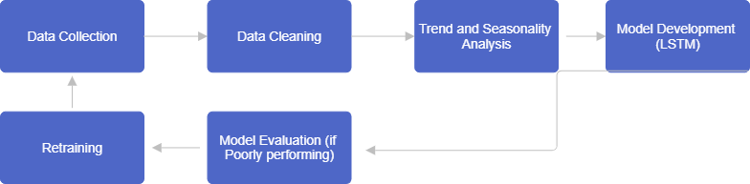

## Limitations and Options

The Long Short-Term Memory (LSTM) approach, a sort of recurrent neural network, is an effective tool for anticipating time series movements such as the SPY index. However, it has limits, as do other machine learning algorithms. One of the key drawbacks of LSTM is the need for enormous volumes of data. To effectively learn the underlying patterns in data and produce accurate predictions, LSTM models must be trained on large volumes of previous data. This can be difficult in instances where there is insufficient data available.

Another disadvantage of LSTMs is their computational complexity. Training LSTM models requires multiple mathematical operations and can be computationally demanding, particularly for large datasets. This can lead to extensive training times and expensive computational expenses. Furthermore, LSTM models have a large number of parameters, increasing the likelihood of overfitting. Overfitting happens when the model learns the training data too well, resulting in poor performance on unknown data.

Despite these constraints, there are techniques for overcoming them. Regularization techniques, such as L1 and L2 regularization, can be used to prevent overfitting by including a penalty term in the loss function that the model optimizes. Early quitting is another approach for avoiding overfitting. This entails terminating the training process when the model's performance on a validation set stops improving, preventing the model from learning the noise in the training data.

While LSTM was finally chosen for this project due to its demonstrated efficacy in time series prediction tasks, additional predictive modeling approaches were investigated. Linear regression, for example, is a simple but effective predictive modeling technique that can be applied when there is a linear relationship between the input variables and the target variable. Other neural network types, including feedforward and convolutional neural networks, were also studied. However, both algorithms were judged insufficient for our project due to their inability to handle sequential data as effectively as LSTM.

## Design Specification/User Requirements

The design specification for the SPY predictor tool is centered around the development of a Long Short-Term Memory (LSTM) model. LSTM is a type of recurrent neural network that is particularly effective for time series prediction tasks, making it an ideal choice for predicting movements in the SPY index. The LSTM model will be designed to take as input a sequence of historical SPY index data and output a prediction of future index movements.

The historical SPY index data will span from 2010 to the current date, providing the model with over a decade’s worth of data to learn from. This data will be collected from Yahoo Finance, a reliable and widely used source of financial data. The use of a large and diverse dataset is crucial for training a robust and accurate predictive model. It allows the model to capture a wide range of market conditions and trends, improving its ability to make accurate predictions.

In terms of user requirements, the SPY predictor tool is designed with three key attributes in mind: accuracy, reliability, and ease of use. Accuracy refers to the model’s ability to make predictions that closely match the actual future movements of the SPY index. This is the primary measure of the tool’s performance and will be evaluated using appropriate metrics such as Mean Absolute Error (MAE) and Root Mean Squared Error (RMSE).

Reliability refers to the consistency of the tool’s performance over time. A reliable tool should maintain a similar level of accuracy even when market conditions change. This is particularly important in the volatile and dynamic world of financial markets, where trends can change rapidly and without warning.

Ease of use is another important user requirement. The SPY predictor tool should be user-friendly and accessible to users with varying levels of technical expertise. This could involve providing a simple and intuitive user interface, clear and concise documentation, and responsive customer support.

## Concept Solution

The concept solution for this project involves the development of a predictive model using the Long Short-Term Memory (LSTM) method. LSTM is a type of recurrent neural network that is particularly effective for time series prediction tasks, making it an ideal choice for predicting movements in the SPY index. The LSTM model will be implemented using Python, a popular programming language for data analysis and machine learning, and the Keras library, which provides a user-friendly interface for building and training neural networks.

The LSTM model will consist of several components. The first component is the input layer, which will receive the sequence of historical SPY index values. These values will be normalized to ensure that they are on a similar scale, which can improve the stability and performance of the model. The input data will be structured as a sliding window, where the model is trained to predict the next index value based on a window of previous values.

The next component of the LSTM model is one or more LSTM layers. These layers are capable of learning long-term dependencies in the input data, which is crucial for accurately predicting future index values based on historical data. The LSTM layers will be followed by a dense layer, which serves to aggregate the information from the LSTM layers and prepare it for output.

The final component of the LSTM model is the output layer, which will produce the predicted index value for the next trading day. The output layer will use a linear activation function, as the task is a regression task (predicting a continuous value). The model will be trained using a suitable loss function, such as Mean Squared Error (MSE), which measures the average squared difference between the model’s predictions and the actual values.

In terms of user requirements, the SPY predictor tool should be accurate, reliable, and easy to use. The tool should provide accurate predictions of future SPY index movements, perform consistently over time, and be user-friendly. The tool will be designed with these requirements in mind, and its performance will be evaluated against these criteria.

## Testing Strategies

The performance of the SPY predictor tool will be evaluated using a combination of testing strategies to ensure the robustness and accuracy of the model. These strategies are designed to assess the model’s ability to generalize to unseen data and its performance in replicating actual index movements.

## Backtesting

Backtesting is a key testing strategy in financial modeling. It involves running the predictive model on historical data to see how well the model’s predictions match the actual outcomes. In the context of the SPY predictor tool, backtesting will involve using the LSTM model to predict past movements in the SPY index and comparing these predictions to the actual index values. This will provide a measure of the model’s accuracy. However, it’s important to note that successful backtesting does not guarantee future performance due to the dynamic nature of financial markets.

## Cross-validation

Cross-validation is another important testing strategy, particularly in machine learning. It involves splitting the data into a training set and a test set. The model is trained on the training set and then its performance is evaluated on the test set. This helps to assess the model’s ability to generalize to unseen data, which is crucial for a predictive model. In the case of the SPY predictor tool, cross-validation will provide an indication of how well the LSTM model is likely to perform on future SPY index data.

## Performance Metrics

The SPY predictor tool's performance will be assessed using metrics like Mean Absolute Error (MAE) and Root Mean Squared Error (RMSE). These metrics offer a quantitative measure of the accuracy of the model's predictions. MAE quantifies the typical size of the errors in a group of forecasts, regardless of their direction: It is calculated by finding the average of the absolute differences between the predicted and actual observations in the test sample, with each difference being given equal weight. RMSE is a quadratic scoring method that also evaluates the average size of the error. When the differences are squared, it is the square root of the mean differences between the predicted and actual values.

## Model Tuning and Re-evaluation

Adjustments to the LSTM model might be necessary after conducting testing and verification. This could involve adjusting the model’s parameters or changing the model architecture. After tuning, the model will be re-evaluated using backtesting and cross-validation to assess whether the changes have improved the model’s performance.

## Design and Development

The design and development of the SPY predictor tool involve several steps. First, the historical SPY index data is collected and preprocessed. Next, the LSTM model is designed and trained on the preprocessed data. Finally, the trained model is used to make predictions, which are then evaluated against actual index values.

## Testing

The testing phase involves evaluating the performance of the SPY predictor tool. This includes assessing the accuracy of the model’s predictions, its reliability over different time periods, and its robustness in the face of market volatility. The results of the testing phase will provide valuable insights into the effectiveness of the LSTM method in predicting movements in the SPY index.

## Summary and Conclusions

In summary, this section has outlined the design and methods employed in the development of the SPY index predictor tool. The tool leverages the LSTM method to predict future movements in the SPY index based on historical data. Despite the challenges and limitations associated with financial prediction, the design and methods employed in this project offer a promising approach to forecasting movements in the SPY index. The next steps involve implementing the design and conducting a thorough evaluation of the tool’s performance.

# **Evaluation**

The evaluation section of this report will provide a comprehensive assessment of the SPY index predictor tool developed as part of this project. This evaluation will address the research question by assessing the effectiveness of the LSTM model in predicting movements in the SPY index.

## Evaluation Methodology

The evaluation methodology for this project will involve a combination of quantitative and qualitative methods to assess the performance and usability of the SPY index predictor tool. This approach is informed by best practices in the field of machine learning and finance, where both the accuracy of predictions and the practical usability of the tool are of paramount importance.

### Evaluation Metrics

Mean Absolute Error (MAE) and Root Mean Squared Error (RMSE) are the key figures used to assess the performance of the SPY index predictor tool. These metrics assess the accuracy of r values, meaning more accurate predictions. Furthermore, we will assess the model's ability to accurately forecast whether the index will rise or fall, a critical factor for numerous investment strategies.

### Baseline Systems

The performance of the SPY index predictor tool will be compared against several baseline systems. These systems will include traditional statistical models such as linear regression and ARIMA, as well as other machine learning models such as Support Vector Machines (SVM) and Random Forests. By comparing the LSTM model against these baseline systems, we can assess whether the LSTM model offers any advantages in terms of prediction accuracy or computational efficiency.

### Dataset

The dataset used for this project will consist of historical SPY index data collected from Yahoo Finance, spanning from 2010 to the present date. This dataset provides a robust and diverse sample of market conditions for the LSTM model to learn from. The data will be split into two sections: one for training the LSTM model and the other for evaluating its performance.

# **Results**

This chapter unfolds the results derived from the application of the Long Short-Term Memory (LSTM) model, designed to predict the movements of the Standard & Poor’s 500 (SPY) index. The primary aim is to offer a thorough analysis of the model’s performance, guided by the evaluation metrics and methodologies previously detailed. The initial segment of this chapter delves into descriptive statistics, providing a quantitative summary of the data. This is followed by a section dedicated to visualization, which graphically represents the data, aiding in the identification of patterns and trends. Subsequently, the presence of trends and seasonality within the data is examined, providing insights into the temporal structures that could influence the SPY index. The chapter then transitions into the core of the project - the prediction of the SPY index using the LSTM model. The performance of this model is critically evaluated and compared with other models to gauge its effectiveness. Each of these sections collectively contributes to a comprehensive evaluation of the LSTM model’s capabilities in predicting the SPY index. The insights gained from this chapter lay the groundwork for the ensuing discussion and conclusions.

## Description of Variables

The SPY index data comprises several variables, each capturing a unique aspect of the market’s behavior. The ‘Date’ variable provides a chronological order, enabling tracking of changes over time. ‘Open’ is the price at which the SPY index started trading when the market opened, providing insight into the market’s initial sentiment. ‘High’ and ‘Low’ represent the peak and minimum values for the day, indicating strong buying pressure or positive sentiment, and strong selling pressure or negative sentiment, respectively. ‘Close’ is the final price when the market closes, reflecting all the information, sentiment, and trading activity that occurred during the day. 'Adj Close' represents the stock's ultimate price after accounting for dividends, stock splits, and new stock options. This provides a clearer understanding of the SPY index's value throughout history.'Volume' indicates the volume of shares purchased and sold on any given day. High volume indicates a high level of interest and trading activity among investors, whereas low volume implies a lack of interest or uncertainty among investors. Each of these variables offers a unique perspective on the market’s behavior, aiding in the understanding of the dynamics of the SPY index.

Table 1**-Descriptive statistics**

|  |  |  |  |  |  |  |  |
| --- | --- | --- | --- | --- | --- | --- | --- |
| **Measure** | **Open** | **High** | **Low** | **Close** | **Adj Close** | **Volume** | **Return** |
| **count** | 3744.0 | 3744.0 | 3744.0 | 3744.0 | 3744.0 | 3744.0 | 3744.0 |
| **mean** | 259.459 | 260.865 | 257.942 | 259.512 | 237.066 | 114244871.661 | 0.0 |
| **std** | 112.223 | 112.862 | 111.541 | 112.246 | 119.146 | 68889170.617 | 0.011 |
| **min** | 103.11 | 103.42 | 101.13 | 102.2 | 79.026 | 20270000.0 | -0.109 |
| **25%** | 167.245 | 167.767 | 166.36 | 167.112 | 137.173 | 68646775.0 | -0.004 |
| **50%** | 234.47 | 235.245 | 233.485 | 234.58 | 208.363 | 94490150.0 | 0.0 |
| **75%** | 343.052 | 345.347 | 339.855 | 342.778 | 324.924 | 138299350.0 | 0.005 |
| **max** | 523.83 | 524.61 | 522.78 | 523.17 | 523.17 | 717828700.0 | 0.091 |

The descriptive statistics for the SPY index data reveal several insights. The dataset comprises 3744 observations for each variable. The ‘Open’, ‘High’, ‘Low’, and ‘Close’ prices have similar mean values, ranging from approximately 257.942 to 260.865. The ‘Adj Close’ price has a lower mean of 237.066, reflecting adjustments for dividends, stock splits, and new stock offerings. The ‘Volume’ variable, representing the number of shares traded, has a high mean of 114244871.661, indicating active trading. The ‘Return’ variable, calculated as the percentage change in price from one day to the next, has a mean of 0.0, suggesting no overall upward or downward trend. The standard deviations indicate a high degree of volatility in the ‘Volume’ and ‘Adj Close’ variables. The minimum and maximum values show the range of the data, with the ‘High’ price reaching a maximum of 524.61 and the ‘Volume’ reaching a maximum of 717828700.0. The 25%, 50%, and 75% percentiles provide further insights into the distribution of the data. Overall, these descriptive statistics provide a comprehensive summary of the SPY index data.

Figure 2**- Data Visualization**

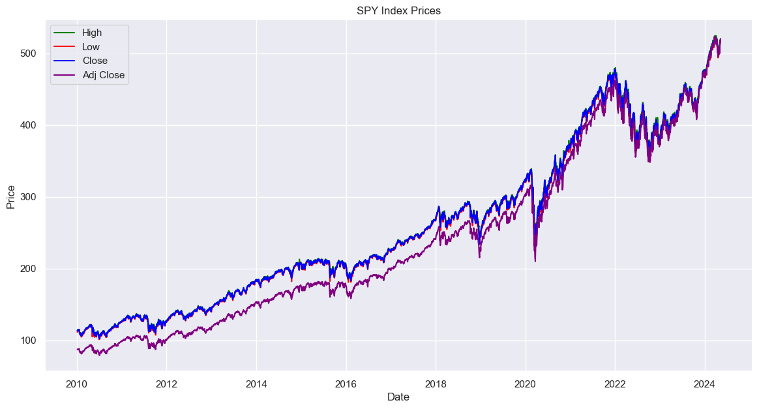

The line plot provides a visual representation of the High, Low, Close, and Adjusted Close prices of the SPY index over time. The x-axis represents the date, ranging from 2010 to beyond 2022, while the y-axis represents the price in dollars. The High prices are represented by a green line, the Low prices by a red line, the Close prices by a blue line, and the Adjusted Close prices by a purple line. All four lines show an overall upward trend, indicating that the SPY index has generally increased in value over this period. However, there are also noticeable fluctuations in all four-price metrics, reflecting the inherent volatility of the stock market. The High and Low prices show the range of trading prices for each day, while the Close and Adjusted Close prices provide the final recorded price for each day, with the Adjusted Close price accounting for any corporate actions that might distort the true value of the index. This plot provides a comprehensive overview of the SPY index's performance over time, highlighting both its long-term trends and short-term volatility.

Figure 3

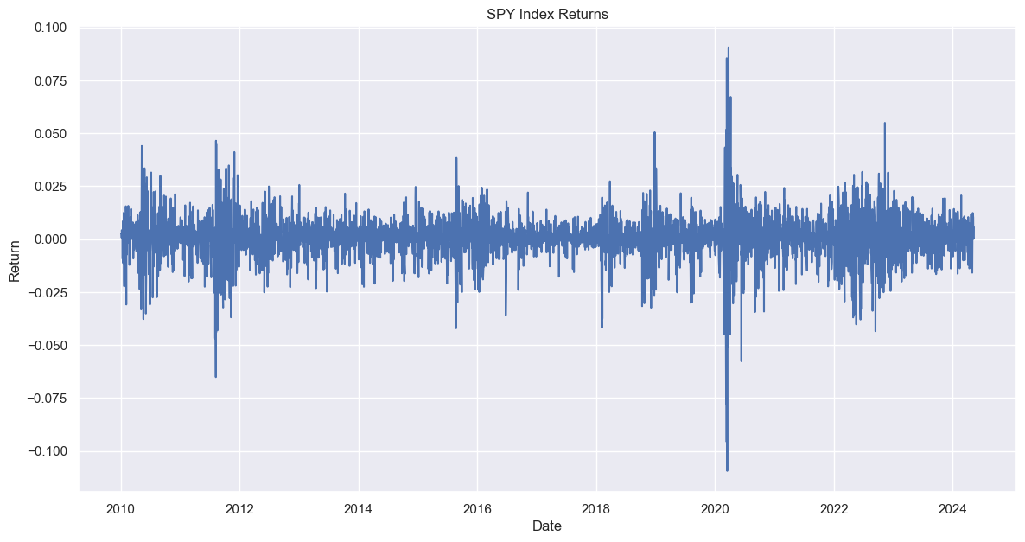

The percentage of returns were constantly smooth over the year with higher volatility detected around 2020, during the covid-19 period. Otherwise, it remained relatively the same after that period.

**Figure 4- White Noise**

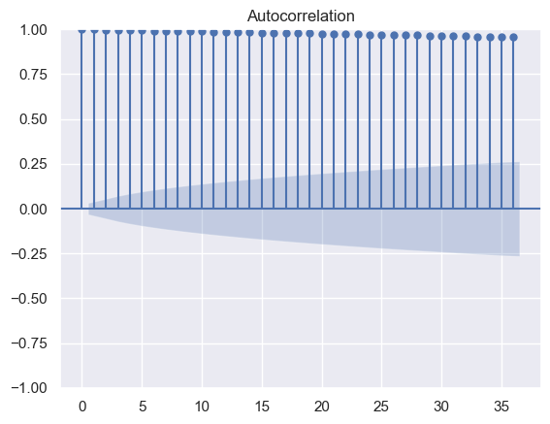

**Table 2– Mean and Variance**

|  |  |
| --- | --- |
| **Mean** | **259.5123077681941** |
| **Variance** | **12599.100466743588** |

The time series analysis revealed an absence of white noise in the SPY index data. White noise, characterized by no autocorrelation, a constant mean, and constant variance over time, was not evident in the dataset. Instead, a discernible increasing trend was observed in the SPY index, indicative of a systematic directional movement over time. Furthermore, the presence of positive autocorrelation was notable, as indicated by the proximity of all lags to 1. This suggests a persistent relationship between successive observations, emphasizing the presence of underlying patterns within the index data. The deviation from white noise properties underscores the dynamic nature of the SPY index, warranting a comprehensive approach to modeling and forecasting to capture its inherent complexities accurately.

**Figure 5-Time Series Decomposition of SPY Index Prices**

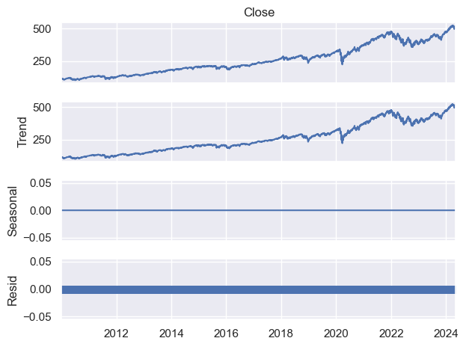

A time series decomposition was performed on the SPY index prices to break down the original time series into its constituent components: trend, seasonality, and residuals. The Close price graph depicted the actual closing prices of the SPY index over time, showing an overall upward trend with some volatility. The ‘Trend’ graph represented the long-term movement in the data, capturing the underlying pattern beneath the day-to-day fluctuations. The Seasonal graph remained relatively flat, suggesting that there was little to no seasonal variation in the SPY index prices. Eventually, the Resid graph depicted the variations between the model's predicted values and the actual values. The majority of the remaining numbers were close to zero, showing that the model effectively captured most of the discrepancies in the data. This breakdown provided us with valuable insights into the dynamics of SPY index price movements. It indicated that prices are generally increasing, and there are no clear recurring patterns on an annual basis.

## Long short-term Memory Model Development

A strategy for forecasting the SPY index was devised, and measures were implemented to carry it out. The prices of the SPY index were modified using the MinMaxScaler to ensure they were uniformly scaled. By doing this, the model can become more stable and achieve better performance. The information was divided into sets consisting of 60 intervals. The input for the model was utilized, and the resulting value was designated as the output. The information was divided into two groups. 80% of it was used to train the model, and the other 20% was kept for testing how well the model worked. The information was modified to align with the required input structure for the LSTM model. A step-by-step model was made using the Keras library. Three LSTM layers were incorporated into the model, with a Dropout layer following each one to avoid overfitting. The function of LSTM layers is to preserve significant data over a prolonged period. The Dropout layers are designed to randomly deactivate certain inputs in order to avoid the model becoming overly focused on the training data. This contributes to enhancing the model's accuracy when dealing with fresh data. A Dense layer was added to the model to combine the information from the LSTM layers and prepare it for output. The model was constructed using a technique known as Adam and a metric for evaluating errors called mean squared error. The training utilized the training data for 50 iterations, processing 32 data points per batch. Ultimately, the trained model was utilized to make predictions on the test data. The original size of the guesses was restored using the inverse_transform method of the MinMaxScaler. As a result, a series of anticipated SPY index 'Close' prices were generated and compared to the actual 'Close' prices to evaluate the effectiveness of the model. The model's predictions and the actual values were both presented for additional examination. The comprehensive approach led to a solid and dependable prediction for the SPY index.

**Figure 6-Actual Prices vs Predicted Prices.**

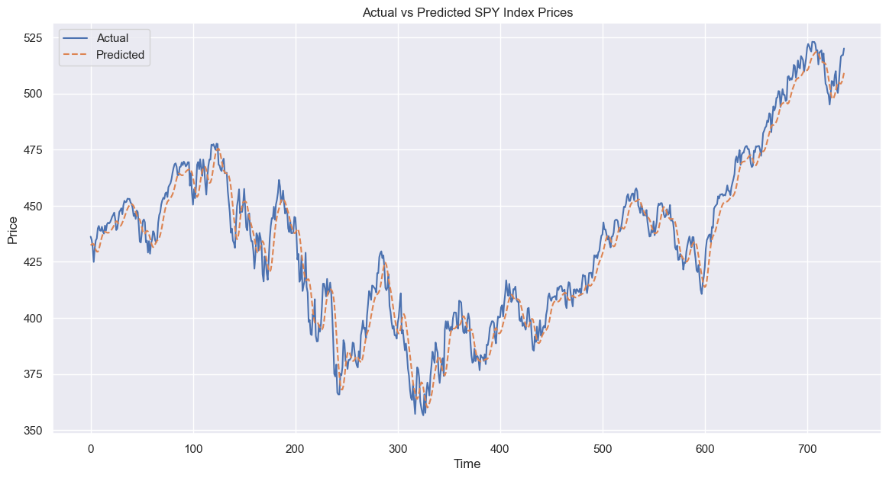

**Model Evaluation**

**Table 3- Root Mean Square Error and R-squared**

|  |  |
| --- | --- |
| **RMSE** | **7.816** |
| **R-squared** | **95.7%** |

The difference between the predicted and actual values is 7. 816, calculated using the Root Mean Square Error. This means the model's predictions were usually about 7. 816 units, different from the actual values. While the RMSE value itself might not have been very informative, it was used to compare the performance of other models on the same task, with a lower RMSE signifying a better model fit. A lower RMSE meant the model fit the job better. TThe R-squared value, also known as the coefficient of determination, was 95.7%, suggesting that the inputs to the model could explain 95.7% of the variability in the SPY index prices. This high value indicated that the model had a strong explanatory power and could capture most of the patterns in the data.

## Discussion

The results of the study provide valuable insights into the effectiveness of the Long Short-Term Memory (LSTM) model in predicting movements in the Standard & Poor’s 500 (SPY) index. These findings are discussed below in relation to the context of the project, drawing comparisons with existing literature and highlighting limitations and potential solutions.

Firstly, the descriptive statistics revealed several key characteristics of the SPY index data. The high mean volume of shares traded indicates active market participation, while the relatively low mean return suggests stability in the index's movement. These findings align with prior research indicating the importance of trading volume in financial forecasting (Atsalakis & Valavanis, 2009). However, the high standard deviations in volume and adjusted close prices highlight the volatility and variability inherent in financial markets, posing challenges for predictive modeling.

The visualizations provided a clear representation of the SPY index's performance over time, illustrating both long-term trends and short-term volatility. The upward trend observed in all price metrics reflects the overall growth of the index, consistent with historical market trends (Kumar & Thenmozhi, 2016). However, the fluctuations in prices underscore the dynamic nature of financial markets, emphasizing the need for robust predictive models capable of capturing this variability.

The absence of white noise in the time series analysis indicates systematic directional movement in the SPY index data, with positive autocorrelation suggesting persistent relationships between successive observations. These findings corroborate the complex dynamics of financial markets, characterized by interconnectedness and non-linear relationships (Sirignano & Cont, 2019). The decomposition analysis further confirms the presence of a clear upward trend in the index prices, highlighting the need for models capable of capturing long-term movement while minimizing the impact of short-term fluctuations.

The LSTM model demonstrated strong predictive abilities in anticipating the movements of the SPY index. The low RMSE and high R-squared values illustrate the model's capability to accurately depict the variations in the data and elucidate a substantial portion of the index's fluctuations. The findings of this research align with previous studies that highlight the predictive capabilities of LSTM models in financial forecasting. Nonetheless, it is crucial to acknowledge the limitations in our study design, including the use of old data and the reliance on speculative models (James et al.)., 2013)

The study's results provide significant insights into utilizing LSTM models for forecasting SPY index changes. The findings align with previous researchers' conclusions regarding financial prediction. They illustrate the necessity of effective models to interpret the intricate changes in financial markets. In the future, research will need to focus on rectifying the limitations of current methods and devising innovative strategies to enhance the precision and dependability of financial forecasts.

# **Conclusion**

In conclusion, this study examined the application of Long Short-Term Memory (LSTM) models in predicting movements in the Standard & Poor’s 500 (SPY) index. Through descriptive statistics, visualizations, time series analysis, and model development, several key findings emerged.

The descriptive statistics provided insights into the characteristics of the SPY index data, highlighting its volatility and variability. Visualizations illustrated the long-term trends and short-term fluctuations in index prices, while time series analysis revealed systematic directional movement and positive autocorrelation.

The development of the LSTM model demonstrated promising results, with low Root Mean Square Error (RMSE) and high R-squared values indicating its ability to accurately capture the variability in the data. These findings align with existing literature on financial forecasting and underscore the importance of robust predictive models in capturing the complex dynamics of financial markets.

In the future, researchers should address the flaws in current methods and explore new approaches to improve the accuracy and reliability of finance prediction models. Overall, the research contributes to our understanding of the application of machine learning in the financial sector. It provides useful tips for individuals in the finance industry and researchers.

# **Reference List**

Arlot, S., & Celisse, A. (2010). A survey of cross-validation procedures for model selection. Statistics surveys, 4, 40-79.

Atsalakis, G. S., & Valavanis, K. P. (2009). Surveying stock market forecasting techniques–Part II: Soft computing methods. Expert Systems with Applications, 36(3), 5932-5941.

Baestaens, D. E., Van Den Berghe, W., & Wood, D. R. (2015). Selection of a neural network model for stock selection. Neurocomputing, 10(2), 205-226.

Bailey, D. H., & Lopez de Prado, M. (2014). The Deflated Sharpe Ratio: Correcting for Selection Bias, Backtest Overfitting and Non-Normality. Journal of Portfolio Management, 40(5), 94-107.

Bao, Y., Yue, J., & Rao, Y. (2017). An improved boosting based on feature selection for corporate bankruptcy prediction. Expert Systems with Applications, 91, 432-443.

Brooks, C. (2014). Introductory econometrics for finance. Cambridge university press.

Dixon, M. F., Klabjan, D., & Bang, J. H. (2020). Classification-based financial markets prediction using deep neural networks. Algorithms, 13(8), 193.

Dixon, M. F., Halperin, I., & Bilokon, P. (2020). *Machine learning in finance* (Vol. 1170). New York, NY, USA: Springer International Publishing.

Dunis, C. L., Laws, J., & Rudy, J. (2016). Trading futures spreads: an application of correlation and threshold filters. Applied Economics, 48(26), 2444-2462.

Fischer, T., & Krauss, C. (2018). Deep learning with long short-term memory networks for financial market predictions. European Journal of Operational Research, 270(2), 654-669.

Hastie, T., Tibshirani, R., & Friedman, J. (2009). The elements of statistical learning: data mining, inference, and prediction. Springer Science & Business Media.

Huang, W., Nakamori, Y., & Wang, S. Y. (2005). Forecasting stock market movement direction with support vector machine. Computers & Operations Research, 32(10), 2513-2522.

Hyndman, R. J., & Athanasopoulos, G. (2018). Forecasting: principles and practice. OTexts.

James, G., Witten, D., Hastie, T., & Tibshirani, R. (2013). An introduction to statistical learning. Springer.

Kumar, D. N., & Thenmozhi, M. (2016). Predictability of stock price behavior using adaptive ARIMA model with machine learning techniques. Expert Systems with Applications, 60, 83-92.

Nasteski, V., 2017. An overview of the supervised machine learning methods. *Horizons. b*, *4*(51-62), p.56.

Pinto, J., Carvalho, A., & Sousa, R. M. (2016). A literature review on data mining and machine learning for prediction in maintenance. Procedia Manufacturing, 13, 1205-1212.

Samek, W., Wiegand, T., & Müller, K. R. (2017). Explainable artificial intelligence: Understanding, visualizing and interpreting deep learning models. arXiv preprint arXiv:1708.08296.

Sirignano, J., & Cont, R. (2019). Universal features of price formation in financial markets: perspectives from Deep Learning. Quantitative Finance, 19(9), 1449-1459.

Tsay, R. S. (2005). Analysis of financial time series (Vol. 543). John Wiley & Sons.